COHFMA Student Scholarship Program
Association & Academic Year: 2025/2026
(June 2025 – May 2026)

The Central Ohio Chapter of the Healthcare Financial Management Association (COHFMA), Student Scholarship Program, offers the opportunity for students pursuing any healthcare management profession to obtain financial assistance for a specified variety of categories. COHFMA membership includes central and southeastern Ohio areas.

The categories of scholarship offered are:
- Level 1: Executive Chair - Tuition Assistance ($1,000 award) + HFMA Student Membership Fee ($50 award)
- Level 2: Committee Chair - Tuition Assistance ($250 award) + HFMA Student Membership Fee ($50 award)
- Level 3: Student Ambassador - HFMA Student Membership Fee ($50 award)

Scholarships are awarded for academic achievement, demonstration of leadership potential, service activities, technical skills, and communication skills. Specifically, for the tuition assistance, award will also be subject to demonstrating the desire to commit to engaging in committee participation with the COHFMA Leadership Team.

Applications must be submitted by Friday, March 7, 2025, by 5pm.

Applicant Eligibility
To qualify for consideration for any category of scholarship offered, all applicants must meet the following minimum requirements:
- Candidate must have full-time student status and pursuing a healthcare management or related program of study at the time the scholarship is awarded and may be undergraduate, graduate, or doctoral student.
- Undergraduate students must have a minimum of 60 credit hours completed when scholarship is awarded.
- Previous Level 1 tuition winners are ineligible for future Level 1 awards. Level 2 tuition and Level 3 award winners ARE eligible for future any level awards.
- Previous tuition applicants who were not selected are eligible but must reapply.
- Previous ambassadors/membership fee winners are eligible but must reapply.

Review Criteria
Specific to Tuition Awards (Level 1 & Level 2) Review Criteria:
- Application -PLUS-
- Resume -PLUS-
- Letter(s) of Recommendation, maximum 2
  - Each letter should include the recommender’s position and comment about the student’s leadership potential, technical, and communication skills.
  - Recommender should email, with clear indication of student, the letter directly to: hfma.centralohio@gmail.com.

Review Criteria (cont.)
Specific to Student Ambassador - Membership Award Review Criteria:
- Student Ambassador Application – separate application. Apply here: 2025-2026 COHFMA Student Ambassador Application

Conditions of Tuition Award (Executive Chair & Committee Chair)
Level 1: Executive Chair - Awardee will agree to chair, with the support of a seasoned Leadership Member, the established Student Leadership Committee. Time commitment is approximately 6-8 hours/month beginning June 2025. Appointment to lead this committee will be one (1) year.

Level 2: Committee Chair – Awardee will agree to chair one of the Student Leadership Subcommittees. Time commitment is approximately 4-5 hours/month beginning June 2025. Appointment to lead a subcommittee will be one (1) year. The Committees currently available:
- Communications
- Lives Back
- Membership
- Networking
- Programming
Please review summary of subcommittees within application materials on website

Conditions of Membership Award (Student Ambassador)
Level 3: Ambassador - The main requirement for the Student Ambassador scholarship is active participation within the organization. Over the Fall and Spring semesters, ambassadors will be expected to accumulate a total of 10 points by completing activities listed in the table below.
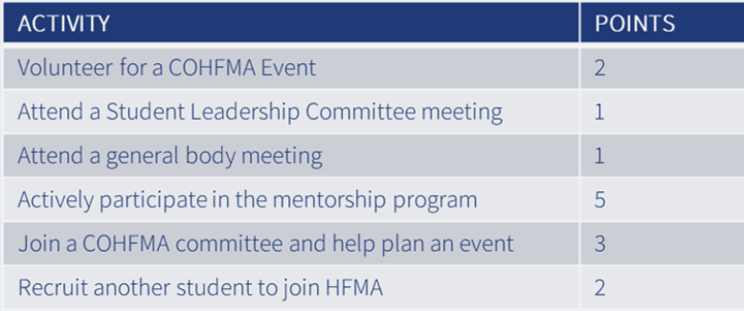

Questions
Please contact the COHFMA Leadership Team with any questions or concerns by emailing us at hfma.centralohio@gmail.com.

Find Us Here:


HFMA Central Ohio Chapter Vimeo Central Ohio HFMA


www.CentralOhioHFMA.org

COHFMA Student Scholarship Program
Association & Academic Year: 2025/2026
(June 2025 – May 2026)
Tuition Award - APPLICATION FORM

I am submitting this application for (check all that apply):

☐ Tuition Award – Level 1 Executive Chair ☐ Tuition Award – Level 2 Committee Chair

☐ Membership Award – Level 3 Student Ambassador – STOP. Please fill out Student Ambassador Application here: 2025-2026 COHFMA Student Ambassador Application

APPLICANT INFORMATION

Student Full Name: ______________________________________________________________

Permanent Mailing Address: ______________________________________________________

Primary Contact Phone Number: ___________________________________________________

E-mail Address: _________________________________________________________________

Mailing Address (if different than above): ____________________________________________

DEGREE/PROGRAM

☐ Undergraduate ☐ Graduate ☐ Doctorate

Academic Institution: ____________________________________________________________

College & Department: ___________________________________________________________

Major/Program: ________________________________________________________________

Academic Advisor: ______________________________________________________________

Current Program Cumulative GPA: _________________________________________________
PERSONAL STATEMENT
Please prepare a personal statement about how you view yourself today and your future vision including career goals upon completion of your program in a healthcare management profession. In addition, please describe why you would like to be involved in the Central Ohio Chapter of the Healthcare Financial Management Association. (500 word maximum)

LEADERSHIP STATEMENT - May apply for both
If interested in the Level I – Executive Chair ($1,000), Awardee will agree to lead, with the support of a seasoned Leadership Member, the Student Leadership Committee. Time commitment is approximately 6-8 hours/month beginning June 2025. Appointment to a committee will be one (1) association year. Provide a brief statement on the desire to lead the Student Leadership Committee for the association year. (350 word maximum)

If interested in the Level 2 – Committee Chair ($250), Awardee will agree to lead one of the Student Leadership Subcommittees based on their interest and the needs of the COHFMA Student Leadership and Chapter Leadership Team. Time commitment is approximately 4-5 hours/month beginning June 2025. Appointment to a committee will be one (1) association year. Please indicate which committee you would be willing to lead (review summary of subcommittees within application materials on website):
  - Communications
  - Membership
  - Networking
  - Programming
  - Gives Back
Provide a brief statement on the desire to lead a student subcommittee for the association year. (350 word maximum)

ATTESTATION
I verify the information provided in this application is complete and accurate to the best of my knowledge.

Applicant Signature: _____________________________________________________________

Date: _____________

